Bradley Reardon

Time Series Forecasting and Analysis

HW6

2. 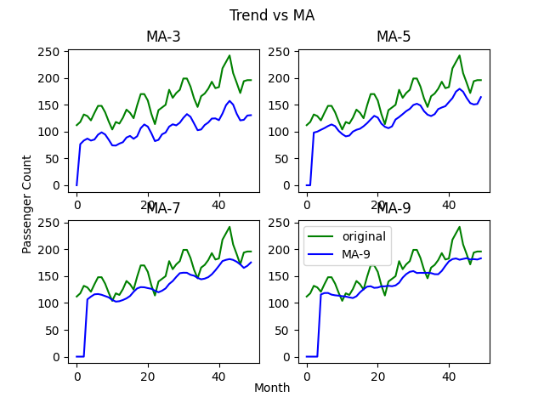

3. 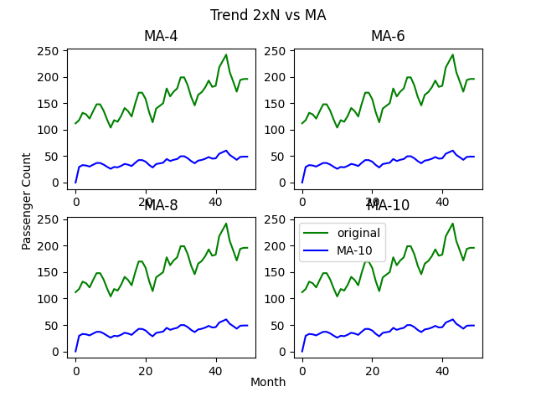

4. 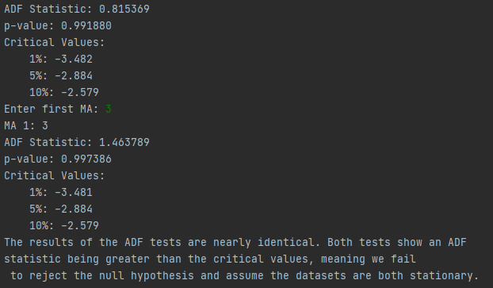

5. 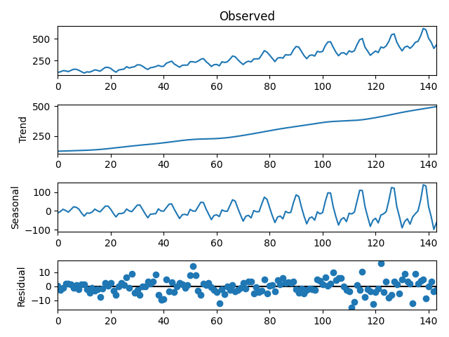

6. 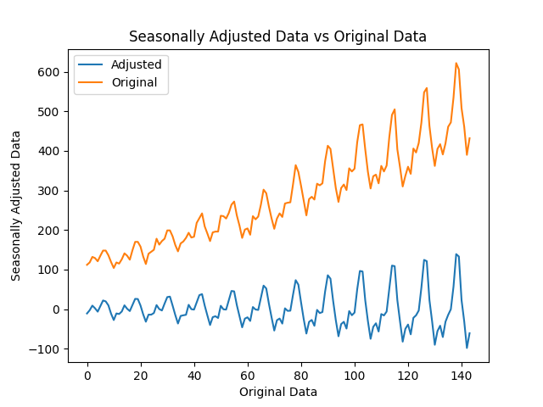

7 & 8. 

9. According to the strength of seasonality and trend values, this dataset is neither strongly seasonal or trended since both values are close to zero.

import numpy as np  
import pandas as pd  
import matplotlib.pyplot as plt  
from toolbox import simulate_MA, ADF_Cal, seasonality_strength  
from statsmodels.tsa.seasonal import STL  
  
# question 1  
df = pd.read_csv(r'C:\Users\brear\OneDrive\Desktop\Grad School\Time-Series-Analysis-and-Moldeing\Datasets\AirPassengers.csv')  
passengers = df['#Passengers']  
  
t1, t2 = simulate_MA(passengers)  
  
plt.plot(t1)  
plt.title('t1')  
plt.show()  
  
plt.plot(t2)  
plt.title('t2')  
plt.show()  
  
  
# question 2  
t3 = simulate_MA(passengers)  
t5 = simulate_MA(passengers)  
t7 = simulate_MA(passengers)  
t9 = simulate_MA(passengers)  
fig, ax = plt.subplots(2,2)  
ax1, ax2, ax3, ax4 = ax.flatten()  
fig.suptitle('Trend vs MA')  
ax1.plot(passengers[:50], label='original', c='g')  
ax1.plot(t3[:50], label='MA-3', c='b')  
ax2.plot(passengers[:50], label='original', c='g')  
ax2.plot(t5[:50], label='MA-5', c='b')  
ax3.plot(passengers[:50], label='original', c='g')  
ax3.plot(t7[:50], label='MA-7', c='b')  
ax4.plot(passengers[:50], label='original', c='g')  
ax4.plot(t9[:50], label='MA-9', c='b')  
ax1.set_title('MA-3')  
ax2.set_title('MA-5')  
ax3.set_title('MA-7')  
ax4.set_title('MA-9')  
plt.tight_layout  
plt.legend(loc='upper left')  
fig.text(0.5, 0.04, 'Month', ha='center')  
fig.text(0.04, 0.5, 'Passenger Count', va='center', rotation='vertical')  
plt.show()  
  
# question 3  
t_first, t4 = simulate_MA(passengers)  
t_second, t6 = simulate_MA(passengers)  
t_third, t8 = simulate_MA(passengers)  
t_fourth, t10 = simulate_MA(passengers)  
fig, ax = plt.subplots(2,2)  
ax1, ax2, ax3, ax4 = ax.flatten()  
fig.suptitle('Trend 2xN vs MA')  
ax1.plot(passengers[:50], label='original', c='g')  
ax1.plot(t4[:50], label='MA-4', c='b')  
ax2.plot(passengers[:50], label='original', c='g')  
ax2.plot(t6[:50], label='MA-6', c='b')  
ax3.plot(passengers[:50], label='original', c='g')  
ax3.plot(t8[:50], label='MA-8', c='b')  
ax4.plot(passengers[:50], label='original', c='g')  
ax4.plot(t10[:50], label='MA-10', c='b')  
ax1.set_title('MA-4')  
ax2.set_title('MA-6')  
ax3.set_title('MA-8')  
ax4.set_title('MA-10')  
plt.tight_layout  
plt.legend(loc='upper left')  
fig.text(0.5, 0.04, 'Month', ha='center')  
fig.text(0.04, 0.5, 'Passenger Count', va='center', rotation='vertical')  
plt.show()  
  
# question 4  
  
ADF_Cal(passengers)  
ADF_Cal(simulate_MA(passengers))  
  
print('The results of the ADF tests are nearly identical. Both tests show an ADF \nstatistic being greater than the critical values, meaning we fail \nto reject the null hypothesis and assume the datasets are both stationary.')  
  
# question 5  
print("\n")  
print("=========STL DECOMPOSITION============")  
res = STL(np.array(passengers).flatten(), period=12).fit()  
res.plot()  
plt.show()  
  
# question 6  
plt.title("Seasonally Adjusted Data vs Original Data")  
plt.xlabel("Original Data")  
plt.ylabel("Seasonally Adjusted Data")  
plt.plot(df.index, res.seasonal, label='Adjusted')  
plt.plot(df.index, passengers, label='Original')  
plt.legend()  
plt.show()  
  
rt = np.subtract(np.subtract(passengers, res.trend), res.seasonal)  
rt_seasonal = np.subtract(rt, res.seasonal)  
rt_trend = np.subtract(rt, res.trend)  
  
# question 7  
print("The strength of seasonality is: " + str(seasonality_strength(rt, rt_seasonal)))  
# question 8  
print("The strength of the trend is: " + str(seasonality_strength(rt, rt_trend)))